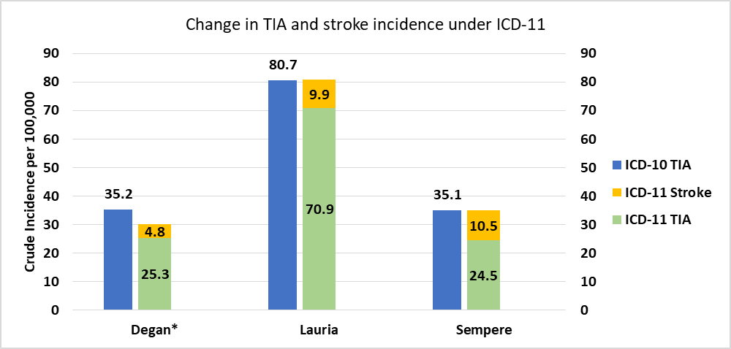
Figure 4: Change in crude incidence of TIA and stroke per 100,000 per year under ICD-11. *The discrepancy in the population size in Degan et al is due to 30 patients being reclassified to a different diagnosis (atypical neurological symptoms) in their study, and not relevant to this review.

